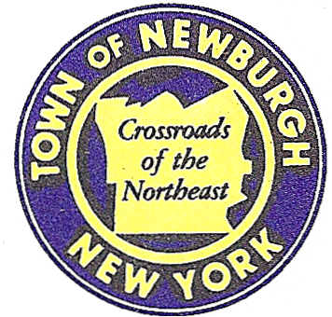

TOWN OF NEWBURGH
_______Crossroads of the Northeast __________________________
OLD TOWN HALL
308 GARDNERTOWN ROAD NEWBURGH, NEW YORK 12550

PLANNING BOARD
JOHN P. EWASUTYN, CHAIRMAN
TELEPHONE 845-564-7804
FAX 845-564-7802
E-MAIL: planningboard@townofnewburgh.org

PLANNING BOARD AGENDA

OCTOBER 16, 2014

*PLEASE NOTE: The Planning Board Meeting will start at 7:00 P.M. and all Applicants/Representatives
are to be present at that time. The Meeting will be held in the Meeting Room of Town Hall,
located at 1496 Route 300, Newburgh NY.*

- Buckeye Terminals LLC (2014-21)  River Road/Oak Street  Section 9, Block 1, Lots 35, 36 & 41  Zone: RI & I  Rep: Borbas Surveying & Mapping, LLC  402 Main Street  Boonton, NJ 07005 | LOT LINE CHANGE/CONSOLIDATION  INITIAL APPEARANCE
- Webb Properties (2014-10)  Route 17K & Auto Park Place  Section 97, Block 2, Lots 35 & 43  Zone: IB  Rep: A. Diachishin & Associates  115 Yankee Folly Road  New Paltz, NY 12561 | SITE PLAN & LOT LINE CHANGE

*WORK SESSION: Project Readiness Discussion scheduled for 5:00 p.m. in the Meeting Room
of Town Hall on Thursday, October 16, 2014*

PLANNING BOARD BUSINESS
WORK SESSION

October 16, 2014
5:00 P.M.

Discussion:

- Patton Ridge Subdivision (2012-18): The Applicant is requesting a six month extension of preliminary approval which will run from November 7, 2014 to May 7, 2015.
- 9W Gas & Convenience Store (2009-14): extension of amended site plan approval.

- Landscaping Security Management

- Valley Contracting Septic Service: Section 185-19.C2

- Toyota of Newburgh – new parking area. Set up for technical work session

- 261 North Plank Road (2014-18): final amended site plan approval.

- Depew Energy (2014-09): final approval.

- Magyar Budget Truck Rental (2011-04): for final amended site plan approval.

